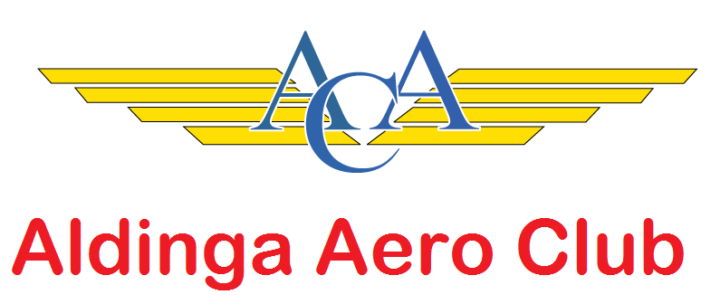
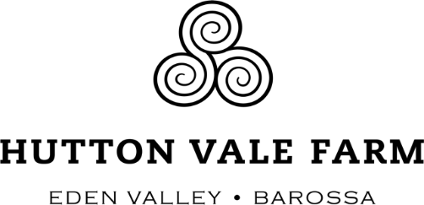

Sunday lunch in the Barossa Valley
NAME: Click to enter. AIRCRAFT REG:. Click to enter
MOBILE PHONE: Click to enter. EMAIL: Click to enter.
ACCOMPANIED BY: Click to enter names.
SPECIAL DIETARY NEEDS: Click to enter

REGISTRATION FEE:
Adults Click to enter @ $45.00 per person $Click to enter
Children 12 - 18 Click to enter @ $25.00 per person $Click to enter
Children under 12 Click to enter Free
TOTAL $Click to enter

PAYMENT: Direct deposit to: Hutton Vale Farm
BSB: 035 079
AC no: 164330
(use name in reference)

Please return your completed form by email by 21st February 2020.

